Vignette effect in photoshop

1. Open Photoshop
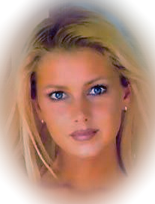

2. Select picture to vignette

Click on select all, you will get running ants around picture

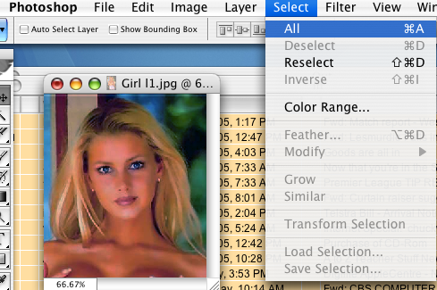

Now click on Select - Modify - Border and select a large border

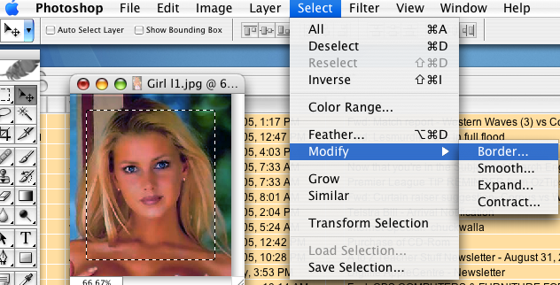

Select box

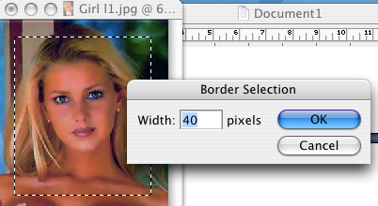

Next click on Filter Guassian Blur… Set this as high as you need

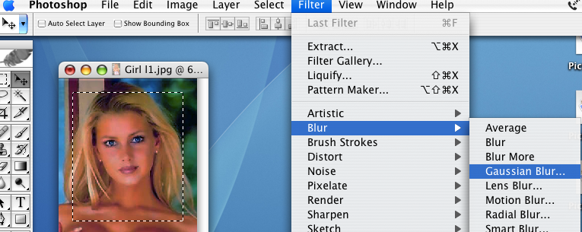

Picture will blur away as a vignette

You can also use the select lassoo to select an image but inverse the selection to add the vignette

or BETTER STILL….

Use the elliptical selector Draw an ellipse over face then copy this

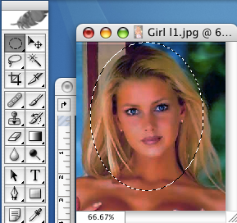

Click new and ensure you paste to a transparent or white background
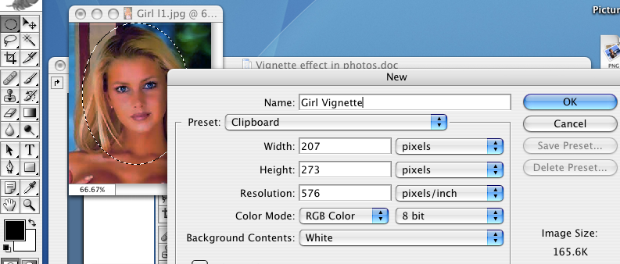

Select the image (use the magic wand) shift click on each white area then inverse the selection

Select Modify Border
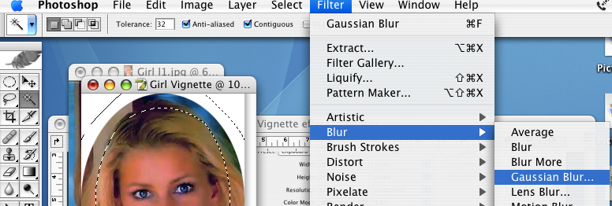

Then Filter Gaussian Blur

Always a better option gives better fade away

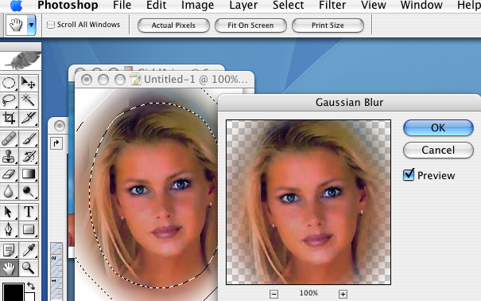

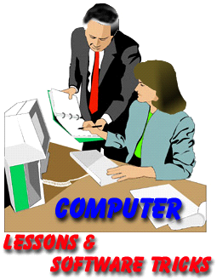

Training prepared by

Prepared by Peter J Faulks
© PIP Multimedia & Training

PO Box 41
Riverton Forum
Western Australia 6148
Phone: 9457 0747
Fax: 9457 0444
Mobile: 0416 187 937

Email : peter@pipmultimedia.com.au
Web: http://www.pipmultimedia.com.au

